Final Website Report

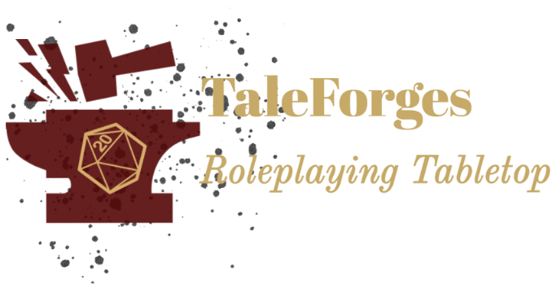

Personal Web Site Report

Gonzalo Sebastian Cascallares

Class: WDD 130-15

December 12, 2022

Introduction

**The subject of the website**

The site is a platform for the development of RPG games of different types such as Dungeons & Dragons, Lotr, Pathfinder, Star Wars, etc. providing tools such as custom dice, thumbnails, character sheets, thematic customization of your account, maps, and many third-party applications for an immersive experience.

**The audience of the website**

The site is fully oriented to Role-Playing games players and new ones who will discover a new world in immersive games with many hours of fun and fast-paced adventures as well as a place to make friends and forge together vibrant online stories.

**The website**

<https://sartentooth.github.io/wdd130/taleforges/index.html>

Goals and Objectives

**The vision**

The goal is to be the first Latin American page dedicated entirely to the development of role-playing games and web applications, both for those who want to play and for those who want to develop through the platform. The 4 goals to achieve this goal are: positioning in the market, audience reach, attracting the creative pole to develop the tools and systems of the website, and promoting the online community: The Tavern.

Design Process

**The vision**

A few years ago I came up with the idea of developing a web application in conjunction with a mobile application of support dedicated to role-playing games not only to play role-playing, but that allowed to develop content for and tools to give diversity to the site and a sense of belonging to the users.

**The Design**

The design came after several days of looking at several related web pages, and templates, and have tried different styles and applications to design the wireframes in the previous works.

I started looking for the images and creating different logos and names for the page since they were the basis and the ones that would give identity and personality to the site. They also inspired me. I had already decided that the colors I would use for the site so I only had to find a tool to unify everything. That tool was Figma since it allowed me not only to make the wireframes but to be able to modify them to my liking and add the colors I had already chosen. The rest was to accommodate the elements and try options until satisfied. It helped a lot to know in advance which images would go on each page and also to find the design. Personally, I like sober and rather minimalist designs, simple but attractive.

**The Color**

I like the pastel and complementary color palettes, they bring sobriety to the site and enhance the simple design. The palette I chose works very well, although it took me a while to find the right colors. They are largely what stands out from the design along with the images, navigation bar, and footer unifying the overall design of the site. I think it's the high point of design in general.

**The Font**

One font to govern them all. From the beginning, I wanted only one typography. Using more fonts eliminated aesthetics and would generate a distraction.

The chosen one was: “Source Sans Pro”

It contributes to the design and style, is clear and legible, does not tire the eye, and interacts very well with the general design and with the other elements of the website. They complete the family of fonts of the site: Helvetica and Sans-serif as secondary fonts.

**The Images**

With the images, I sought to evoke the theme of medieval fantasy, since it is very representative and directs the atmosphere of the site. Set the tone and help understand the message you want to show. I chose each one because they show the different elements from which the role is nourished: dice, sheets, paper, and pencil, and everything else is done by imagination and a good story. And above all the fraternity and brotherhood that is shown in the central image of the Tavern subpage, the toast of the comrades. Additionally, I added in the slideshow of the home page a futuristic image and it is the one that appears in the foreground to show that not only the Middle Ages but any time is excellent to develop a good story and amazing characters.

Conclusion

**Expectative vs Reality**

Honestly, the whole process has been difficult and I have been frustrated on many occasions while carrying out the different stages of the final project. My expectation was much higher than my reality. And there I realized how much I lacked knowledge and practice to be able to create a page that a priori, looked very easy to do and had a very simple design.

This learning process earned me a lot of effort, many hours of dedication, and much rethinking until I found a structure that began to work for me, both with HTML and CSS code. Despite not understanding many aspects yet, through this work I can say that I have a minimum base that helped me to achieve the expectation I had at the beginning and to successfully replicate the designs I had generated for the website. I believe and think that I have no problems when designing or proposing a sketch of what I want, I know my tastes and limitations, and even so, taking risks allowed me to achieve my goals despite having done all the work in a week (by a misinterpretation of mine) when in reality I had 3 more weeks to do it. That mistake helped me a lot, and each of the feedback I received throughout the course.

In short, this semester allowed me to grow and trust, to strive and gain new skills that will help me achieve my goals and objectives including being able, soon, to live from this. And to be able to complete this big but for now small project that is TaleForges.